Introduction to AXI-Lite 2
1. Title 2
2. Objective 2
3. Theory (Multi-Level) 2
3.1 Beginner — Simple Intuition 2
3.2 Intermediate — Engineering View 3
3.3 Advanced — Signal/Architecture Level 4
4. Architecture / Concept 4
Standalone AXI-Lite Educational Model 4
AXI-Lite Slave State Machines (from tb_axi_lite_standalone.v) 5
5. Implementation 5
Files in This Module 5
Standalone Testbench Key Tasks (tb_axi_lite_standalone.v) 6
Slave Register Map (axi_lite_slave in standalone TB) 6
6. Lab / Hands-on Section 6
Step 1: Run the Standalone AXI-Lite Testbench 6
Expected Terminal Output 7
Step 2: View Waveforms 7
Step 3: Run Full AXI-UART Testbench 8
7. Waveform / Verification Insight 8
Write Transaction in GTKWave 8
Read Transaction in GTKWave 8
Timing Measurement 8
8. Common Issues & Debug Tips 8
AXI Protocol Violation Checklist 9
9. Summary 9

Introduction to AXI-Lite
Course: PicoRV32 SoC with AXI-Lite & UART Integration
Lab Commands: make axi_sa → make wave

1. Title
Introduction to AXI-Lite — Valid/Ready Handshake and Channel Architecture

2. Objective
By the end of this module, learners will be able to:
- Describe the five AXI-Lite channel types and their direction
- Explain the valid/ready handshake mechanism and its rules
- Trace a complete write transaction (AW → W → B) through waveforms
- Trace a complete read transaction (AR → R) through waveforms
- Run the standalone AXI-Lite testbench (tb_axi_lite_standalone.v) and verify the handshake

3. Theory (Multi-Level)

3.1 Beginner — Simple Intuition
Imagine AXI-Lite as a two-person handshake:
- The master (e.g., a CPU) says “I have something for you” by raising VALID
- The slave (e.g., a peripheral) says “I’m ready to receive” by raising READY
- The actual transfer (handshake) only happens when BOTH are high at the same clock edge
This means the master and slave can independently assert their signals without knowing each other’s timing — a protocol designed for modular, decoupled hardware blocks.
Write operation analogy (posting a letter):
1. You (master) write the address on the envelope → AW channel
2. You put the letter in the envelope (data) → W channel
3. The post office confirms delivery → B channel (response)
Read operation analogy (fetching a file):
1. You request a file by name → AR channel
2. The librarian hands you the file → R channel

3.2 Intermediate — Engineering View
AXI4-Lite is a simplified subset of ARM’s AMBA AXI4 protocol, designed for register-level peripheral access. It has:
Channel | Direction | Signals
Write Address (AW) | Master → Slave | AWADDR[31:0], AWVALID, AWREADY
Write Data (W) | Master → Slave | WDATA[31:0], WSTRB[3:0], WVALID, WREADY
Write Response (B) | Slave → Master | BRESP[1:0], BVALID, BREADY
Read Address (AR) | Master → Slave | ARADDR[31:0], ARVALID, ARREADY
Read Data (R) | Slave → Master | RDATA[31:0], RRESP[1:0], RVALID, RREADY
Handshake Golden Rule: > A transaction occurs at the rising clock edge when VALID AND READY are both 1.
Key constraints: - Master can assert VALID without knowing if slave is ready - Slave can assert READY without VALID being high (pre-ready) - Master MUST NOT de-assert VALID before a handshake completes - BRESP/RRESP = 2'b00 means OKAY (no error) - WSTRB is a byte-enable: bit 0 controls bytes [7:0], bit 1 → [15:8], etc.

3.3 Advanced — Signal/Architecture Level
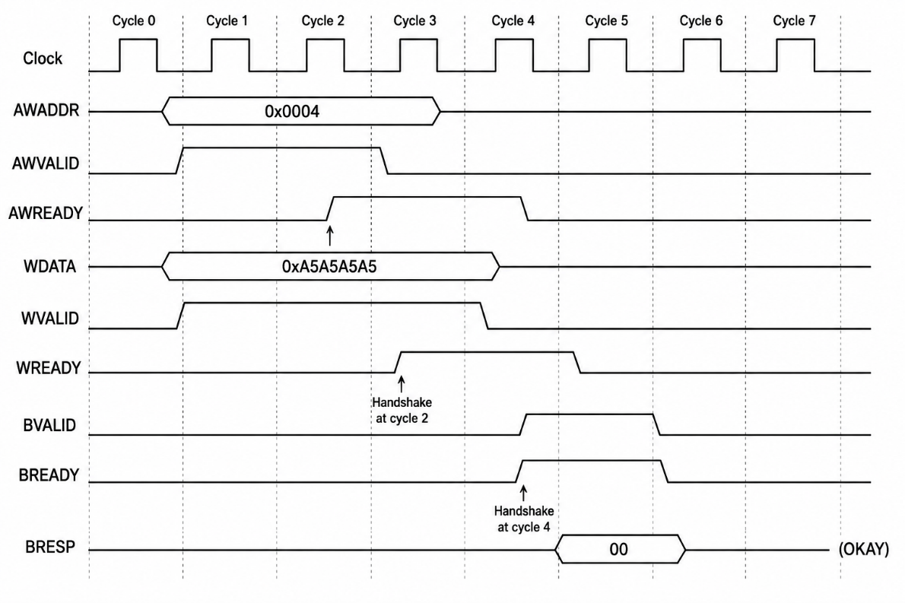
Why separate AW and W channels? This decoupling allows a slave to accept an address before it is ready to accept data, and vice versa — enabling pipelining and burst (in AXI4 full) optimization.
WSTRB encoding:
WSTRB = 4'hF → Write all 4 bytes (common case, 32-bit register write)
WSTRB = 4'h1 → Write byte [7:0] only
WSTRB = 4'h3 → Write bytes [15:0] only
WSTRB = 4'h0 → No write (bypass)

4. Architecture / Concept

Standalone AXI-Lite Educational Model
The testbench tb/tb_axi_lite_standalone.v implements a complete self-contained demonstration:
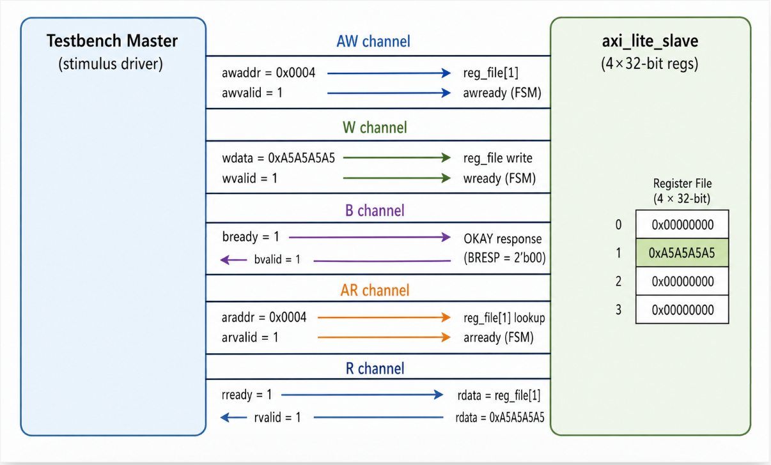

AXI-Lite Slave State Machines (from tb_axi_lite_standalone.v)
Write FSM:
IDLE → (awvalid asserted) → WR_ADDR (latch addr)
WR_ADDR → (wvalid asserted) → WR_DATA (latch data, write to reg)
WR_DATA → (always) → WR_RESP (assert bvalid)
WR_RESP → (bvalid & bready) → IDLE
Read FSM:
IDLE → (arvalid asserted) → RD_ADDR (latch addr, pre-load rdata)
RD_ADDR → (always) → RD_DATA (assert rvalid)
RD_DATA → (rvalid & rready) → IDLE

5. Implementation

Files in This Module
File | Role
tb/tb_axi_lite_standalone.v | Self-contained AXI-Lite slave + master stimulus testbench
tb/tb_axi_lite.v | Full AXI-Lite testbench with UART peripheral
tb/tb_axi_lite_master.v | Reusable AXI-Lite master task library
rtl/axi_lite_interconnect.v | Production AXI-Lite interconnect (1M → 3S)

Standalone Testbench Key Tasks (tb_axi_lite_standalone.v)
Write Task (lines 273–318):
task axi_write;
input [ADDR_WIDTH-1:0] addr;
input [DATA_WIDTH-1:0] data;
// Phase 1: AW channel — present address, wait for awready
// Phase 2: W channel — present data, wait for wready
// Phase 3: B channel — wait for bvalid, de-assert bready
endtask
Read Task (lines 321–351):
task axi_read;
input [ADDR_WIDTH-1:0] addr;
output [DATA_WIDTH-1:0] rd_data;
// Phase 1: AR channel — present address, wait for arready
// Phase 2: R channel — wait for rvalid, latch rdata
endtask

Slave Register Map (axi_lite_slave in standalone TB)
Address | Index | Description
0x0000 | reg_file[0] | Register 0
0x0004 | reg_file[1] | Register 1 (used in lab)
0x0008 | reg_file[2] | Register 2
0x000C | reg_file[3] | Register 3
Address-to-index formula: index = (addr >> 2) % NUM_REGS

6. Lab / Hands-on Section

Step 1: Run the Standalone AXI-Lite Testbench
cd /home/deep/nielit/projects/tested_projects/picorv32_soc
make axi_sa
This command: 1. Cleans obj_axi_sa/ 2. Verilates tb/tb_axi_lite_standalone.v with --binary --trace --timing 3. Runs ./obj_axi_sa/sim_axi_sa → produces tb_axi_lite_standalone.vcd 4. Opens GTKWave

Expected Terminal Output
======================================================
AXI-Lite Standalone Testbench (32-bit addr/data)
======================================================
[TB] Reset applied → All signals initialized
[TB] Starting AXI-Lite Write Transaction...
[WRITE] Address = 0x00000004
[WRITE] Data = 0xa5a5a5a5
[WRITE] awvalid=1, wvalid=0 → Sending address first...
[WRITE] awready=1 → Handshake Done (address 0x00000004 accepted)
[WRITE] wvalid=1 → Sending data 0xa5a5a5a5...
[WRITE] wready=1 → Handshake Done (data accepted)
[WRITE] Waiting for bvalid...
[WRITE] bvalid=1 → Write Response Received (OKAY)
[TB] Starting AXI-Lite Read Transaction...
[READ] Address = 0x00000004
[READ] arvalid=1 → Waiting for arready...
[READ] arready=1 → Handshake Done (address 0x00000004 accepted)
[READ] Waiting for rvalid...
[READ] rvalid=1 → Data Received = 0xa5a5a5a5
[CHECK] Write Data == Read Data → PASS ✓
[TB] AXI-Lite Transaction Successful
======================================================
SUMMARY : Passed = 1 Failed = 0
======================================================
[TB] Simulation Finished

Step 2: View Waveforms
gtkwave tb_axi_lite_standalone.vcd &
Add signals to the wave window in order:
clk
reset
awaddr[31:0]
awvalid
awready
wdata[31:0]
wstrb[3:0]
wvalid
wready
bvalid
bready
bresp[1:0]
araddr[31:0]
arvalid
arready
rdata[31:0]
rvalid
rready
rresp[1:0]

Step 3: Run Full AXI-UART Testbench
make axi_uart

7. Waveform / Verification Insight

Write Transaction in GTKWave
Look for the pattern:
- awvalid rises → address appears on awaddr → wait for awready to rise → AW handshake
- wvalid rises → data appears on wdata → wait for wready to rise → W handshake
- bvalid rises → bready asserted → B handshake (OKAY response)
- All channels de-assert → transaction complete

Read Transaction in GTKWave
- arvalid rises → address on araddr → arready rises → AR handshake
- rvalid rises → rdata has the value → rready asserted → R handshake
- Verify rdata == wdata (0xA5A5A5A5) → data integrity confirmed

Timing Measurement
In GTKWave, use markers to measure: - AW handshake latency: Cycles from awvalid=1 to awready=1 - Write-to-response latency: Cycles from W handshake to B handshake - Read latency: Cycles from AR handshake to R handshake

8. Common Issues & Debug Tips
Issue | Likely Cause | Fix
BVALID never asserts | AW or W handshake never completed | Check both awvalid/awready AND wvalid/wready completed
RVALID never asserts | AR handshake deadlock | Ensure arvalid held until arready seen
Data mismatch on read | Write used wrong WSTRB | Verify WSTRB = 4'hF for full 32-bit write
Bus hangs permanently | Master de-asserted VALID before handshake | Violation of AXI rule: “never de-assert VALID before READY”
Watchdog fires (500 µs) | Handshake deadlock | Add $display inside FSM states to trace which state stuck
Multiple writes overlap | Missing B-channel completion | CPU must wait for BVALID before starting next write

AXI Protocol Violation Checklist
□ AWVALID held until AWREADY seen?
□ WVALID held until WREADY seen?
□ BREADY asserted before or when BVALID was seen?
□ ARVALID held until ARREADY seen?
□ RREADY asserted before or when RVALID seen?
□ No simultaneous multi-master (AXI-Lite = single master)?

9. Summary
Concept | Key Point
5 channels | AW, W, B (write side) + AR, R (read side)
Handshake rule | Transfer occurs when VALID AND READY = 1 at clock edge
WSTRB | Byte-enable mask; 4’hF = full 32-bit write
BRESP/RRESP | 2’b00 = OKAY; no error in this design
Write sequence | AW handshake → W handshake → B response
Read sequence | AR handshake → R data handshake
Lab result | Write 0xA5A5A5A5 → reg[1]; Read back → 0xA5A5A5A5; PASS ✓
Previous: Sub-module 1 — RISC-V ISA
Next: Sub-module 3 — UART Basics

